Status post CHOLECYSTECTOMY AND OTHER POST-OP COMPLICATIONS

Stem: Patient is a 65-year-old man who presents to the emergency department 3 days after laparoscopic cholecystectomy for acute, calculous cholecystitis. He has been having worsening epigastric and RUQ abdominal pain, oral intolerance, chills, fevers, jaundice, darkened urine. He is otherwise without significant past medical or surgical history. Exam: HR 114 bpm, BP 94/37; 94% on RA, 38.8C, Ill appearing, lethargic, jaundice, scleral icterus Mildly distended, TTP in the RUQ and epigastrium. Pertinent labs: WBC 16.4k;Tbili 4.3; AST 143; ALT157; ALK Phos 312; Creatinine 1.73 (normal 0.90)

Discussion
What’s one initial study would you like to order now?
RUQ US –dilated intra and extrahepatic bile ducts with CBD measuring 1.1cm, mild RUQ fluid, and distal common bile duct stone.

How are you going to manage this patient.
- Sepsis workup.
- Resuscitation / hydration/ antibiotics.
- ERCP : You are not credentialed to do it and your GI colleague is on vacation.
- PTC: Your IR colleagues are not available
- Urgent CBD exploration:
  - Open CBD Exploration.
  - Kocherize the duodenum, palpation of the common bile duct to assess location/mobility of the stone, exposure of anterior CBD
  - Place sutures at the 10 and 2 positions and make an anterior vertical ductotomy.
  - Flush duct with small diameter red rubber and pass a biliary Fogartycatheter proximally and distally until all stones are removed.
  - Choledochoscope can be used with wire basket to retrieve challenging stones.
  - Close ductotomy over a 14fr T-tube
  - P erform completion cholangiogram.
  - Leave JP drain.

Scenario 2: Same patient arrives, RUQ US notes intra and extra hepatic ductal dilation, mild fluid, no stone is appreciated. You are now in a tertiary center with all images and expertise available.
- ERCP or MRCP or advanced imaging to delineate etiology→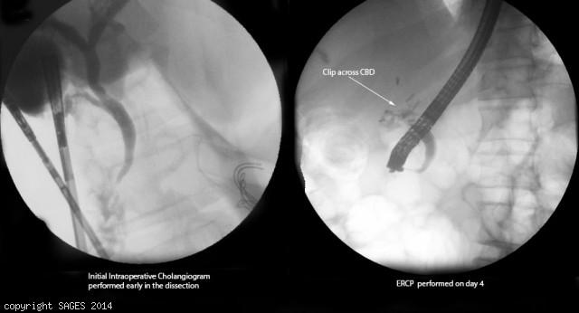
Concern for clip across CBD
- Antibiotics
- IR consultation for PTC.
You take the patient to the OR for repair, how do you repair the following?
- Injury < 50% circumference, not caused by caut ery-Repair over T tube.
- Transection < 1 cm in size and away from bifurcation-End to end anastomosis.
- More severe injury, or close to the bifurcation:Hepaticojejunostomy --Describe.
  - Identify CBD
  - Place two traction sutures on either side of the dilated bile duct.
  - The distal CBD is ligated.
  - T he duct is divided below the traction sutures.
  - The end of the common duct is then trimmed to achieve maximal diameter.
  - fashion a Roux-en-Y jejunal limb
  - This limb is identified and transected with a stapling device 30-35 cm from the ligament of Treitz.
  - A single-layer anastomosis can be performed by a side-to-side anastomosis to the Roux limb
Scenario 3:Same patient however with AST/ALT and Alkphos within normal limits, Tbili slightly elevated to 2.4. RUQ US shows concern for large fluid collection in the RUQ.
1. HIDA:S hows biliary leak.
2. ERCP obtained→cystic duct stump leak confirmed→Sphincterotomy and Stent
3. IR fordrainage of RUQ fluid collection if symptoms do not resolve, persistent leakage or septic.

